# Amazon Certified Solution Architect – Professional

## Holistic Preparation Plan

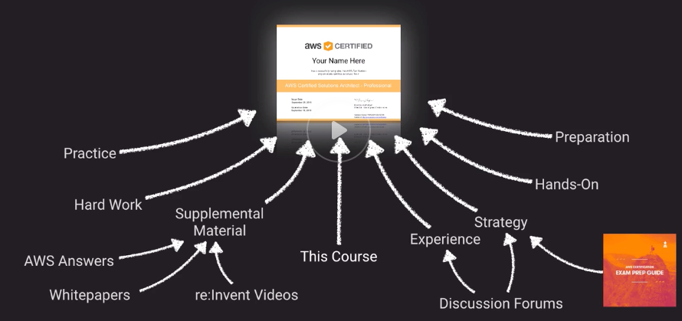

## About the Exam

* Beta Exam: 85 Questions – 220 Minutes
* Multiple Choice & Multiple-answer (3 of 8)
* No Partial Credit
* Score: 100 – 1000; Minimum passing 750

## Exam Blueprint

## Bloom’s Taxonomy

Levels to reach Mastery in AWS

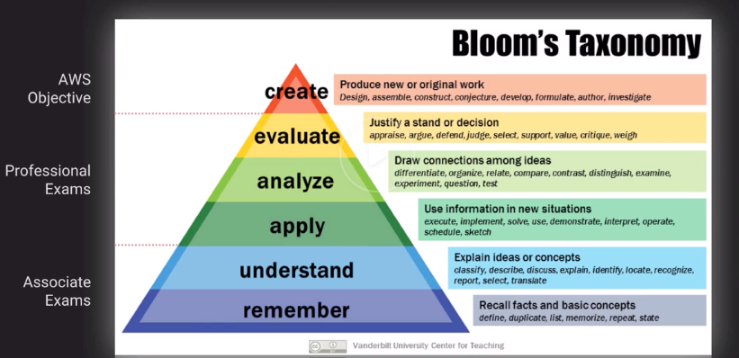

## Dunning Kruger Effect

Most people will face this during preparation

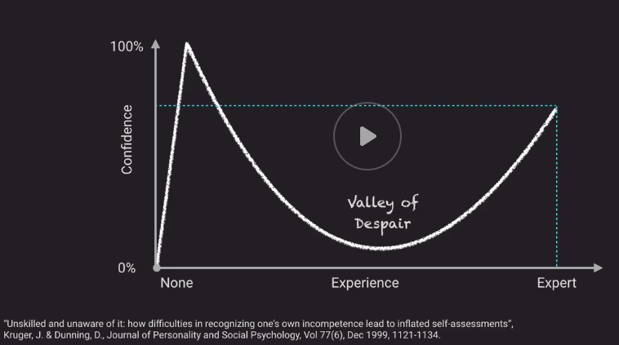

### Key Skills for AWS Certified Architect - Professional

1. Knowledge of AWS
2. Contextual Reasoning
3. Time Management
4. Comprehension Skills
5. Coping under pressure

# Storage Concepts

## Data Persistence

### Persistent Data Store

Data is durable and sticks around after reboots, restarts or power cycles

Ex: Glacier, RDS

### Transient Data Store

Data is just temporarily stored and passed along to another process or persistent store

Ex: SQS, SNS

### Ephimeral Data Store

Data is lost when Stopped

Ex: EC2 Instance Store, Memcached

## IOPS Vs Throughput

### IOPS – Input/Output operations per second

Measure of How fast we can read and write to a device

ToDo:

IOPS of

HDD

SD

Provisioned IOPS

### Throughput

Measure of how much data can be moved at a time

## Consistency

### ACID

A – Atomic (Transactions are “all or nothing”)

C – Consistent (Transactions must be valid)

I – Isolated (Transactions can’t mess with one another)

D – Durable (Completed Transaction must stick-around)

### BASE

BA – Basic Availability (Values available even if stale)

S – Soft-state (Might not be instantly consistent across all data-stores)

E – Eventual Consistency (Will achieve consistency at some point)

TODO: Metrics of ACID and BASE databases for comparison

## S3

S3 can be considered a Database that is replicated in Multiple-AZs

The file-name can be considered the “Key” and the file contents as “Value”

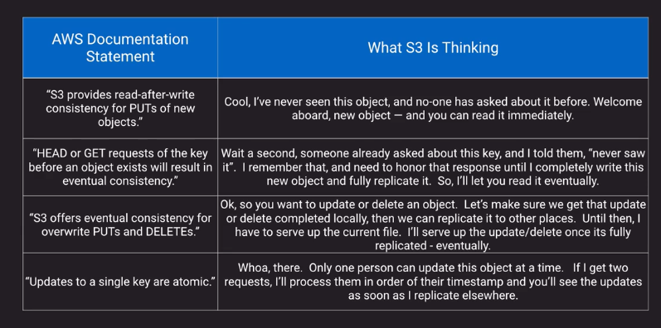

S3 Security

